Metropolitan Public Gardens Association
MPGA Ref No:

……………………..
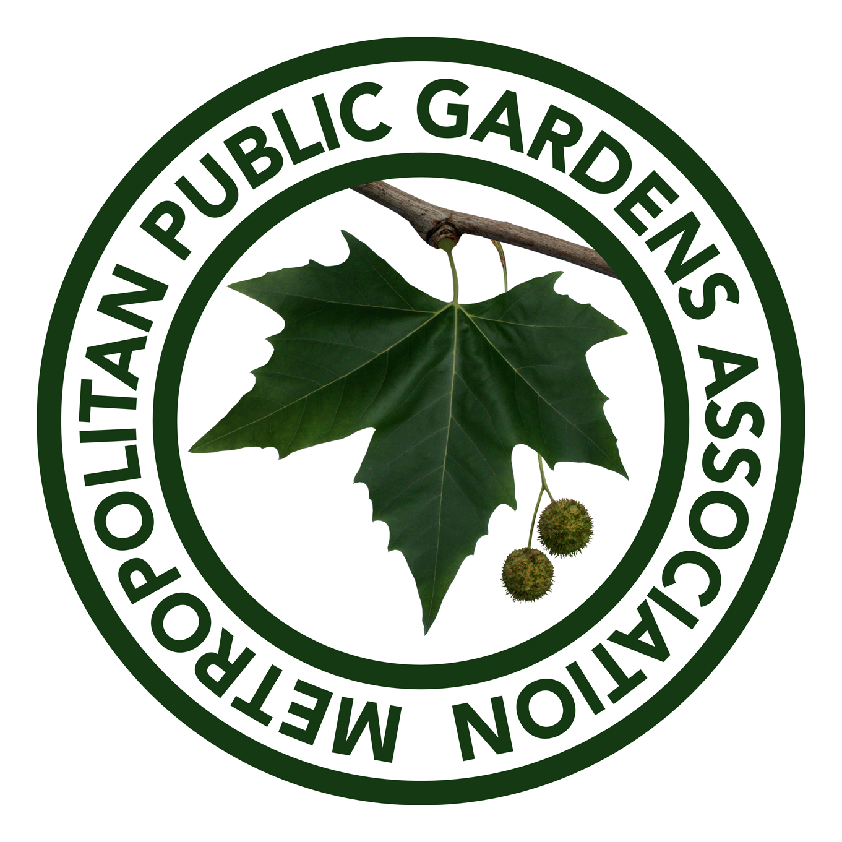
Founded 1882

APPLICATION FOR GRANT

PLEASE NOTE: Applications will only be considered for sites that are accessible to the public free of charge on a regular and frequent basis

Organisation:
Address:
Town: |  |  | Postcode:
London Borough: |  |  | Telephone:
Email:
Website:
Type of organisation:
Charity number: (if appropriate)
Name of contact person:
Email: (if different from above) |  |  |  |  |  |  | Telephone
Position held in organisation:
Name of site (if different from the organisation):
Site description to include
area (m²), special features, surroundings, disability access, information about aspect (including climate such as sunny, shady, dry etc.)
Please attach or insert a scale or dimensioned drawing and digital photos

Please note: if your application is successful photographs and a report will be required on completion of the project

Brief description of the project or proposal:
(Attach additional information if relevant)
Who will benefit from the project?
(Attach additional information if necessary)
Explain how the garden/project will be maintained:
Further comments in support of your application:
Project start date: |  | Project end date:
Please list other funders who might be involved:
How much has been raised?
List organisation and amount:

Overall project cost:
Total MPGA grant requested:
Breakdown of project costs: (Attach additional information including details of contractor and suppliers)

Itemise items/plants you would like to be considered for MPGA grant giving quantity, unit cost, total cost and suppliers.  (PLEASE NOTE WE DO NOT COVER STAFFING, ADMINISTRATION, VOLUNTEER EXPENSES, TRAINING, MAINTENANCE OR HEAVY EQUIPMENT COSTS) |  | Unit cost and quantity | Total cost
If grant application successful, cheque should be made out to and sent to the following address:
Signed: Date:
Print Name:
☐ Tick to confirm you have read and understood the Grant Guidelines document on our website
☐ Tick to confirm you will supply a report and photographs after completion of the project if your application is successful

Please send the completed application and any extra attached information by email to:
Grants Officer at grants@mpga.org.uk

PLEASE NOTE:
• We will not consider grant applications that have not been fully completed or do not include a breakdown of costs.
• All grants are only to be used for the project specified in the application. In the event that the specified project does not proceed (e.g. due to a shortfall in the total project cost) then you are required to return, in total, the MPGA grant awarded.
• The MPGA will require a written report and photographs on completion of the project to show that the funds have been spent as agreed in the award.

The MPGA accepts no responsibility for advice or guidance given by a member of the Association in their performance of any of the activities of the Association. Any such advice or guidance shall be understood to be given by the member acting in his or her personal capacity.

